University Of Engineering and Technology, Lahore Computer Engineering Department

Course Name: PF | Course Code: CMPE-112L
Assignment Type: LAB | Dated: 18 May 2026
Semester: 1st | Session: 2026 Spring
Lab/Project/Assignment #: 10 | CLOs to be covered: CLO
Lab Title: Recursion | Teacher Name: Hafiz Muhammad Mubashar

Lab Evaluation:

CLO1 | Apply appropriate programming techniques to create executable programs to solve well defined problems
 | Level1 | Level2 | Level3 | Level4 | Level5 | Level6
(5)
Total |  |  |  |  |  | /5

Rubrics for Current Lab Evaluation

Scale | Marks | Level | Rubric
Excellent | 5 | L1 | Submitted all lab tasks, BONUS task, have good understanding.
Very Good | 4 | L2 | Submitted the lab tasks but have good understanding
Good | 3 | L3 | Submitted the lab tasks but have weak understanding.
Basic | 2 | L4 | Submitted the lab tasks but have no understanding.
Barely Acceptable | 1 | L5 | Submitted only one lab task.
Not Acceptable | 0 | L6 | Did not attempt

LAB No 10
Lab Goals/Objectives:
- Understand the concept and working of Recursion.
- Learn how a function can call itself repeatedly.
- Create programs using recursive functions.
- Understand the importance of base case and recursive case.

Equipment Required:
- Computer/Laptop

- Python IDE
- Python Interpreter

Theory:
1. Definition Recursion is a programming technique where a function calls itself directly or indirectly to solve a problem. The problem is broken down into smaller, similar subproblems until it reaches a simplest case that can be solved directly.2. Key Components of a Recursive FunctionBase Case: The condition that stops the recursion. Without it, the function will call itself infinitely and cause a stack overflow.Recursive Case: The part where the function calls itself with a smaller/simpler input, moving toward the base case.Recursive Call: The function invokes a new copy of itself.3.
2. How Recursion Works When a recursive function is called, each call is stored in the call stack. The function keeps calling itself until the base case is reached. Then the results start returning back up the stack and combine to give the final answer.4. Types of RecursionDirect Recursion: Function calls itself directly. func() -> func()Indirect Recursion: Function A calls B, and B calls A.Tail Recursion: Recursive call is the last statement in the function.Head Recursion: Recursive call is the first statement.

Lab Work:

Task 1:
Create a function that takes two numbers as parameters, adds them, and returns the result. Call the function with values 1 and 2, and print the returned value.

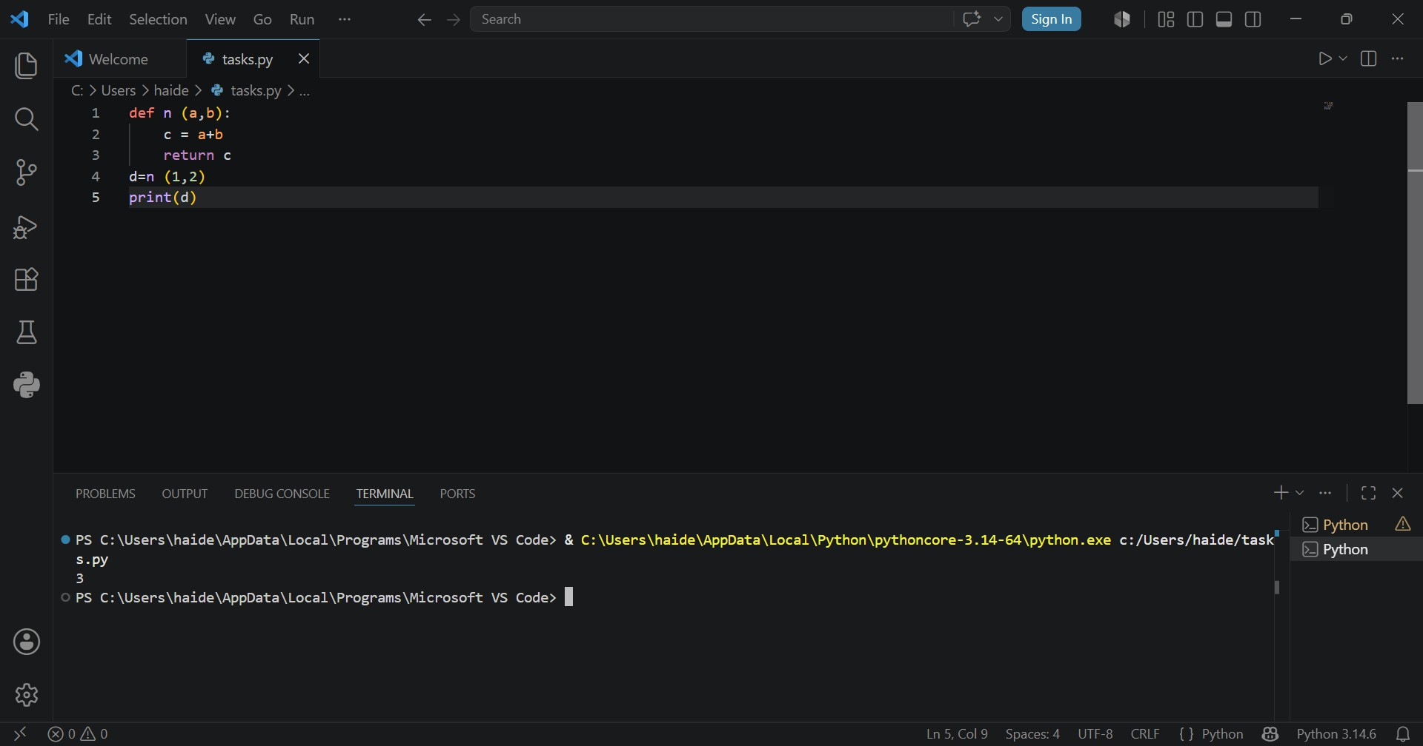
Result:

Task 2:
Write a recursive function that prints numbers from a given number down to 0. Call the function with the value 5.

Result:
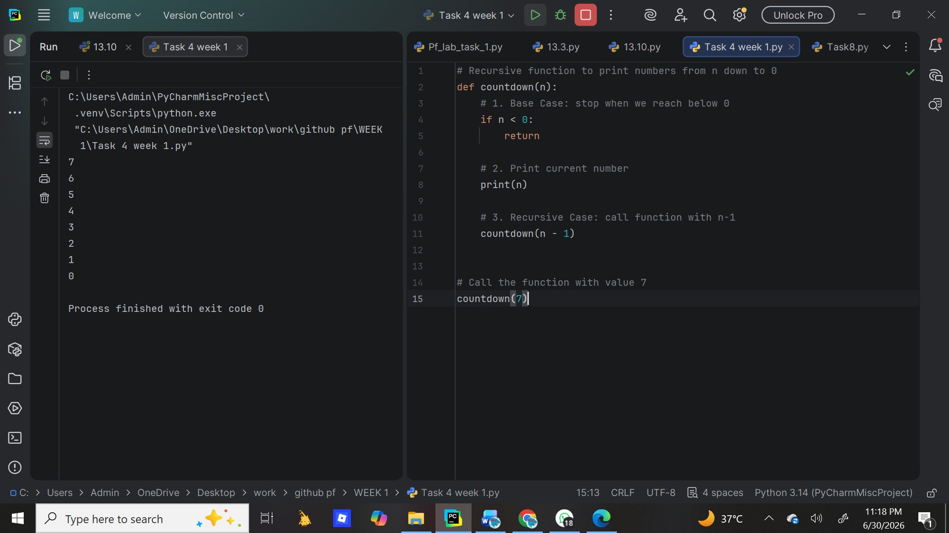

Task 3:
Write a recursive function that returns 1 if the number is 0 or 1, otherwise calls itself with (n-1). Call the function with 6 and print the result.
Result:

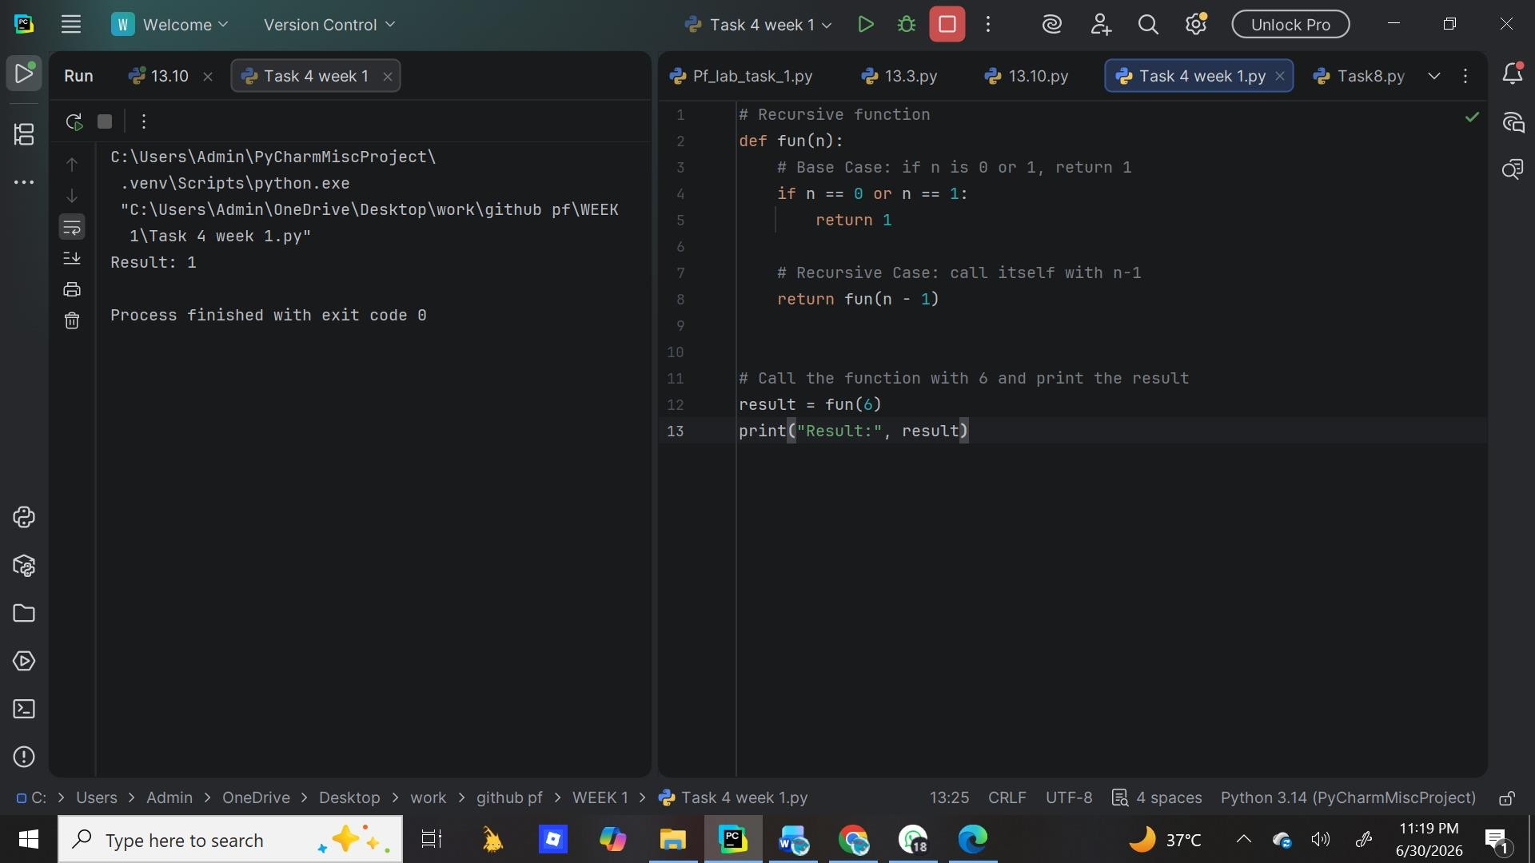

Task 4:
Write a recursive function that returns 1 for base cases (0 or 1), otherwise calls itself with (n-1). Call the function with 6 and print the result.

Result:
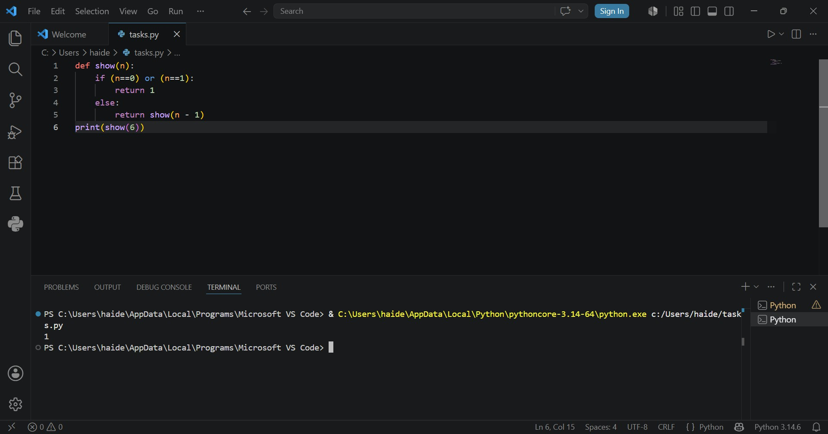

Task 5:
Write a recursive function to calculate the factorial of a number. Take user input, check if it's negative, and print the factorial result.

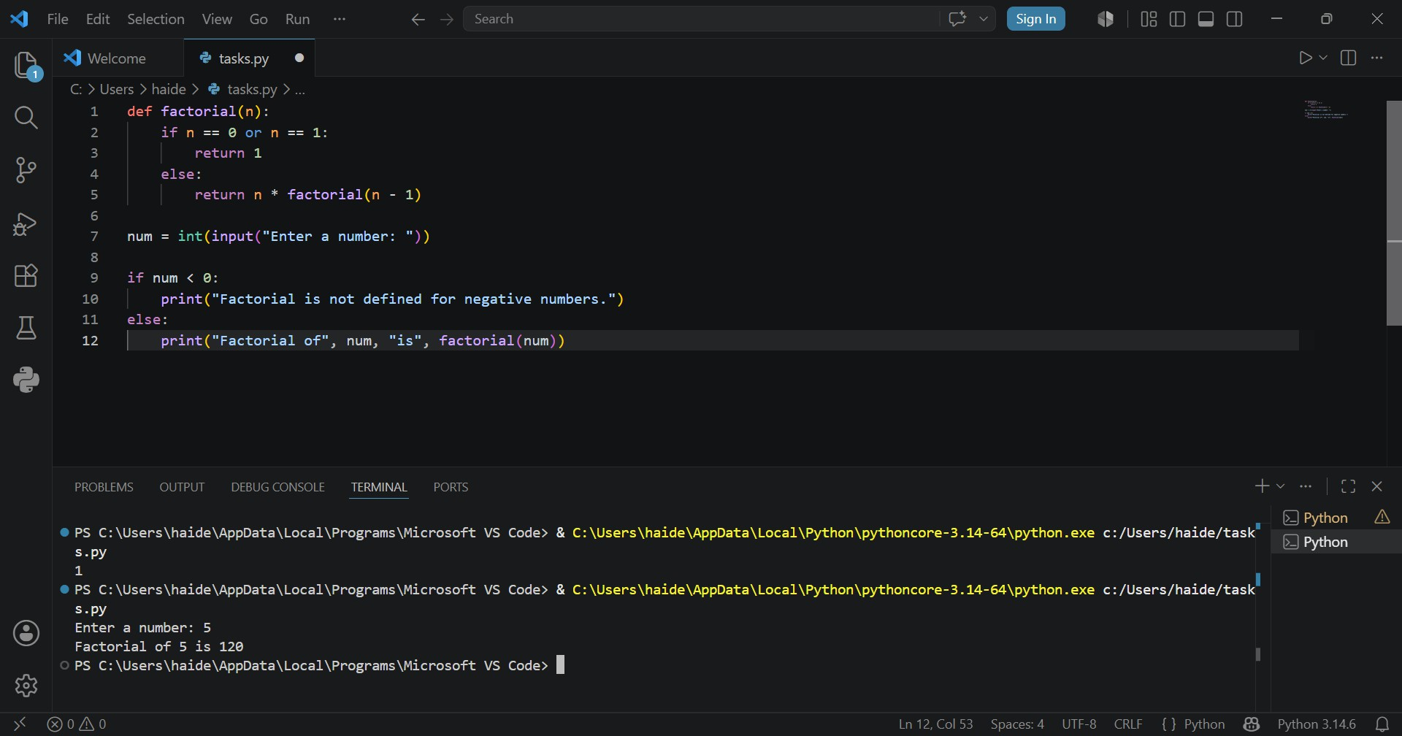
Result:

Task 6:
Write a recursive function to generate the Fibonacci sequence. Print the first 8 Fibonacci numbers using a loop.

Result:
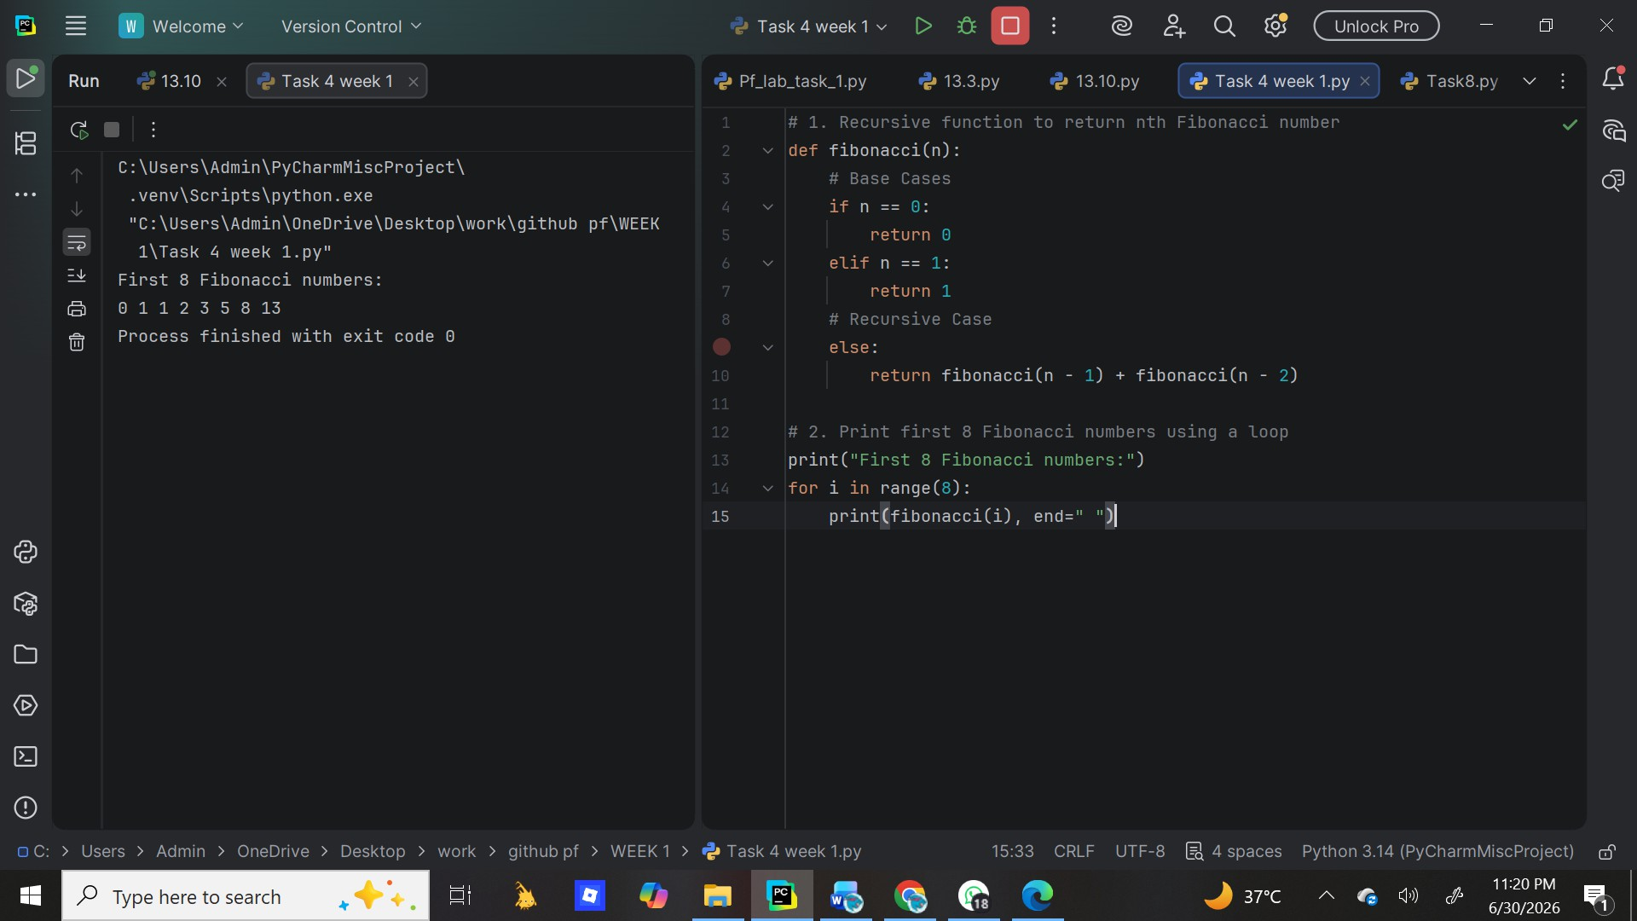

Conclusion:
Recursion is a powerful problem-solving approach that simplifies complex problems by dividing them into smaller sub-problems of the same type. It improves code readability and is ideal for problems with recursive structure like trees and divide-and-conquer algorithms. However, it should be used carefully because of higher memory usage and performance overhead compared to iteration. In practice, recursion is best when clarity is more important than performance, and when the recursion depth is limited. For large data, iterative solutions or tail recursion optimization are preferred.

